Controlling Access
Name
Date
Class
Instructor

Introduction
There is a discussion about the MITRE Corporation risk management related to the resources along with outside data storage. We also include the information about the control mobile access to organizational system users along with specific issues to be addressed with business partners as well as interconnection of the system (Monica Palmirani, 2011).
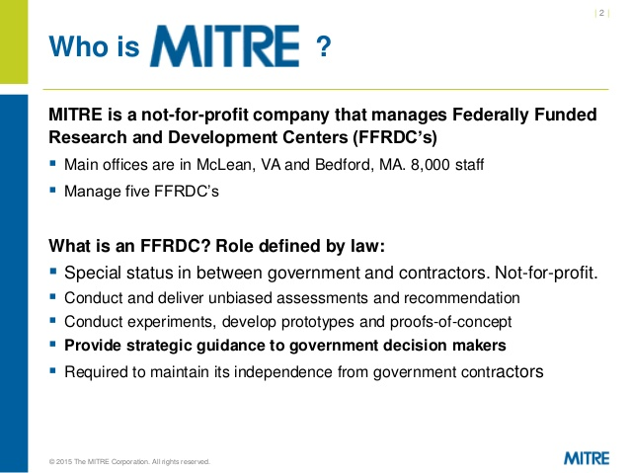
Managing and Control Cloud Resources
MITRE framework engineers (SEs) supporting patrons getting new IT structures, relocating existing IT-based frameworks to the common or shared foundation, or redesigning their internal business frameworks must have a comprehension of the IT Along with related procedures for control, operations, shared utilize, and administration. Miter SEs create exhaustive projects around an ITSM system or approach or address issues correctly prepare regions (Monica Palmirani, 2011).
The remote organization framework is a framework which gives apparatuses along with intuitive UI for a group of cloud assets. Group of cloud assets incorporates design and administration of cloud-based policies. Remote team structure often gives an online entrance to the foreign body. By utilizing this online entry, cloud benefit clients can without much of a stretch oversee and design all the required assets. Real group errands incorporate asset administration, SLA Administration, and Billing Management. Most early cloud usage will be cross breeds of administrations in which keep running on-introduce with authorities conveyed in the cloud (Monica Palmirani, 2011). So, that is the situation that we'll investigate so you can start a continuous move into the cloud without undue dread of loss of control. You will figure out how to manage applications along with administrations powerfully conveyed from an assortment of cloud situations into gadgets like client desktops, Microsoft Terminal Services and a scope of cell phones (Monica Palmirani, 2011).
Recommendation for Mobile Access
We recommend for the organization that all cell phone interchanges be encoded as usual, basically on the grounds in which remote correspondences are so common to catch alongside Snoop. Those same masters go above along with in addition past to recommend in which any correspondences between a wireless alongside an association or cloud-based system or organization require use of a VPN for access to be allowed to happen (Roxanne Burkey, 2000). VPNs not simply consolidate solid encryption, they moreover offer opportunities to logging, organization alongside strong affirmation of customers who wish to use a mobile phone to get to applications, arrangements or remote desktops or structures. Another basic figure is the variety phrasing, for example, using a similar word to mean two distinct things or utilizing several coding records for comparable properties. A prescribed answer for dispense with or diminish miscommunications is to set up information stewardships along with information administration to encourage intervention and peace promotion. What's more, as in most extensive attempts, documentation, and gauges are basic for achievement (Roxanne Burkey, 2000). The disassociation administration is utilized either to constrain a versatile station to take out a relationship with a get to point or for a portable station to educate a get to the point that it no longer requires the administrations of the appropriation framework. At the point when a plant gets to disassociated, it must start another relationship to speak with a get to point once more. A get to may compel a station or stations to disassociate due to asset limitations, the get to point is closing or being expelled from the system for an assortment of reasons (Roxanne Burkey, 2000). At the point when a versatile station knows that it will no longer require the administrations of a get to point, it might summon the disassociation administration to tell the get to the point in which the legitimate association with the authorities of the get to look from this portable station did not require any more.
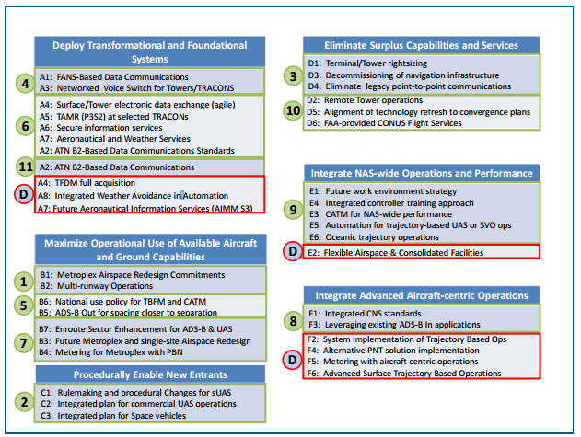
Specific Issues
There are various problems with the business partner and the interconnection systems. Distinctive organization styles don't should be a noteworthy issue. A couple of affiliations go up against parental component: one is a recruit instructor who is task masterminded, insignificantly evacuated along with plan to finish things. The other is free venture, relatable as well as sorts out a "chill" association culture over an inside and out. In a perfect circumstance, one sets out the law and keeps the ship on course, while exchange keeps specialists chipper (Siau, 2006). Common issues between the organizations is an outsider seller called PNI Digital Media that gives photograph preparing sites and administrations for nineteen thousand retail stores. Like the enormous two thousand thirteen Target break in which programmers accessed the organization's system using an unsecured warming and cooling merchant, it shows up developers utilized trusted computerized associations PNI had to these retailers to trade off their frameworks. MITRE’s work for the administration is neither straightforward nor direct (Siau, 2006). Government supports request that MITRE attempts extensive, complex, and now and again one of a kind activities. No single individual at Miter has what it takes to meet these difficulties; nobody component of the association's cooperative scene is "the appropriate response" to hierarchical information and learning. MITRE’s work makes an individual need to work together, forms groups with different expertise sets, and gives frameworks, similar to the MII, to satisfy MITRE’s mission as well as convey the company to shoulder (Siau, 2006). The quality of what Miter does lies in the consistency and interconnection of its classes, objectives, practices, honest along with technologies (Siau, 2006).
Conclusion
We conclude that The Challenge is an energizing and innovative approach to quicken a greater arrangement of thoughts along with answers for the legislature," said Rich Byrne, senior VP and general supervisor of MITRE’s Command along with Control Center, whose thought it was to make the open rivalry. "Our trust is that MITRE can begin giving this constant experimentation setting so that the time from improvement to the application is drastically decreased (Roxanne Burkey, 2000).”

References
Monica Palmirani, D. S. (2011). Rule-Based Modeling and Computing on the Semantic Web: 5th International Symposium, RuleML 2011 - America, Ft. Lauderdale, FL, USA, November 3-5, 2011, Proceedings. Springer.
Roxanne Burkey, C. V. (2000). Designing a Total Data Solution: Technology, Implementation, and Deployment. CRC Press.
Siau, K. (2006). Advanced Topics in Database Research. IGI Global.

